- Execute the script shown in the video.

Environment variables:
export TF_VAR_filename="/root.pets.txt"
export TF_VAR_prefix= "MR"
SYNTAX --> Set-Item -Path env:TF_VAR_filename -Value 'wild.txt'

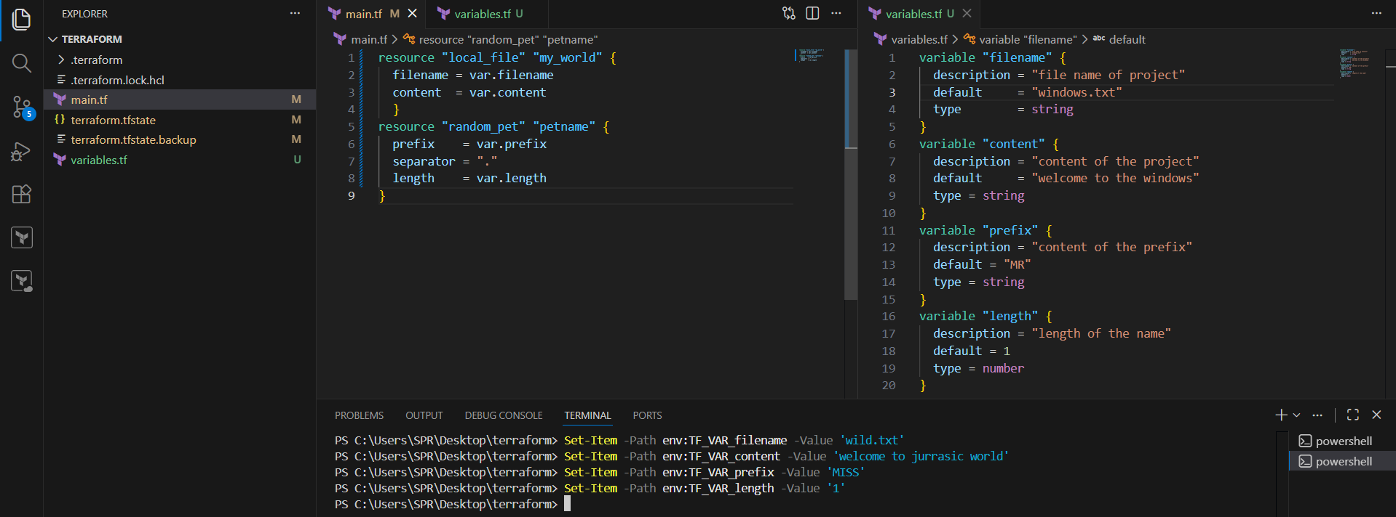

After passing the environment variables , perform terraform apply , it creates the file according to the
Passed values in env variables.

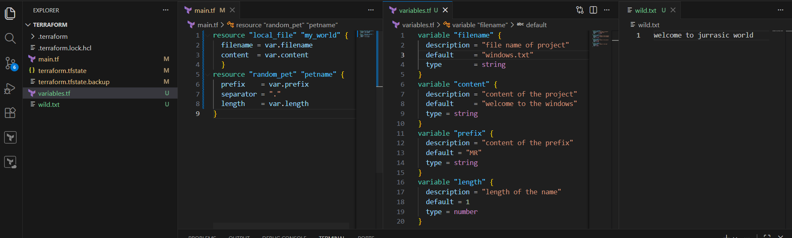
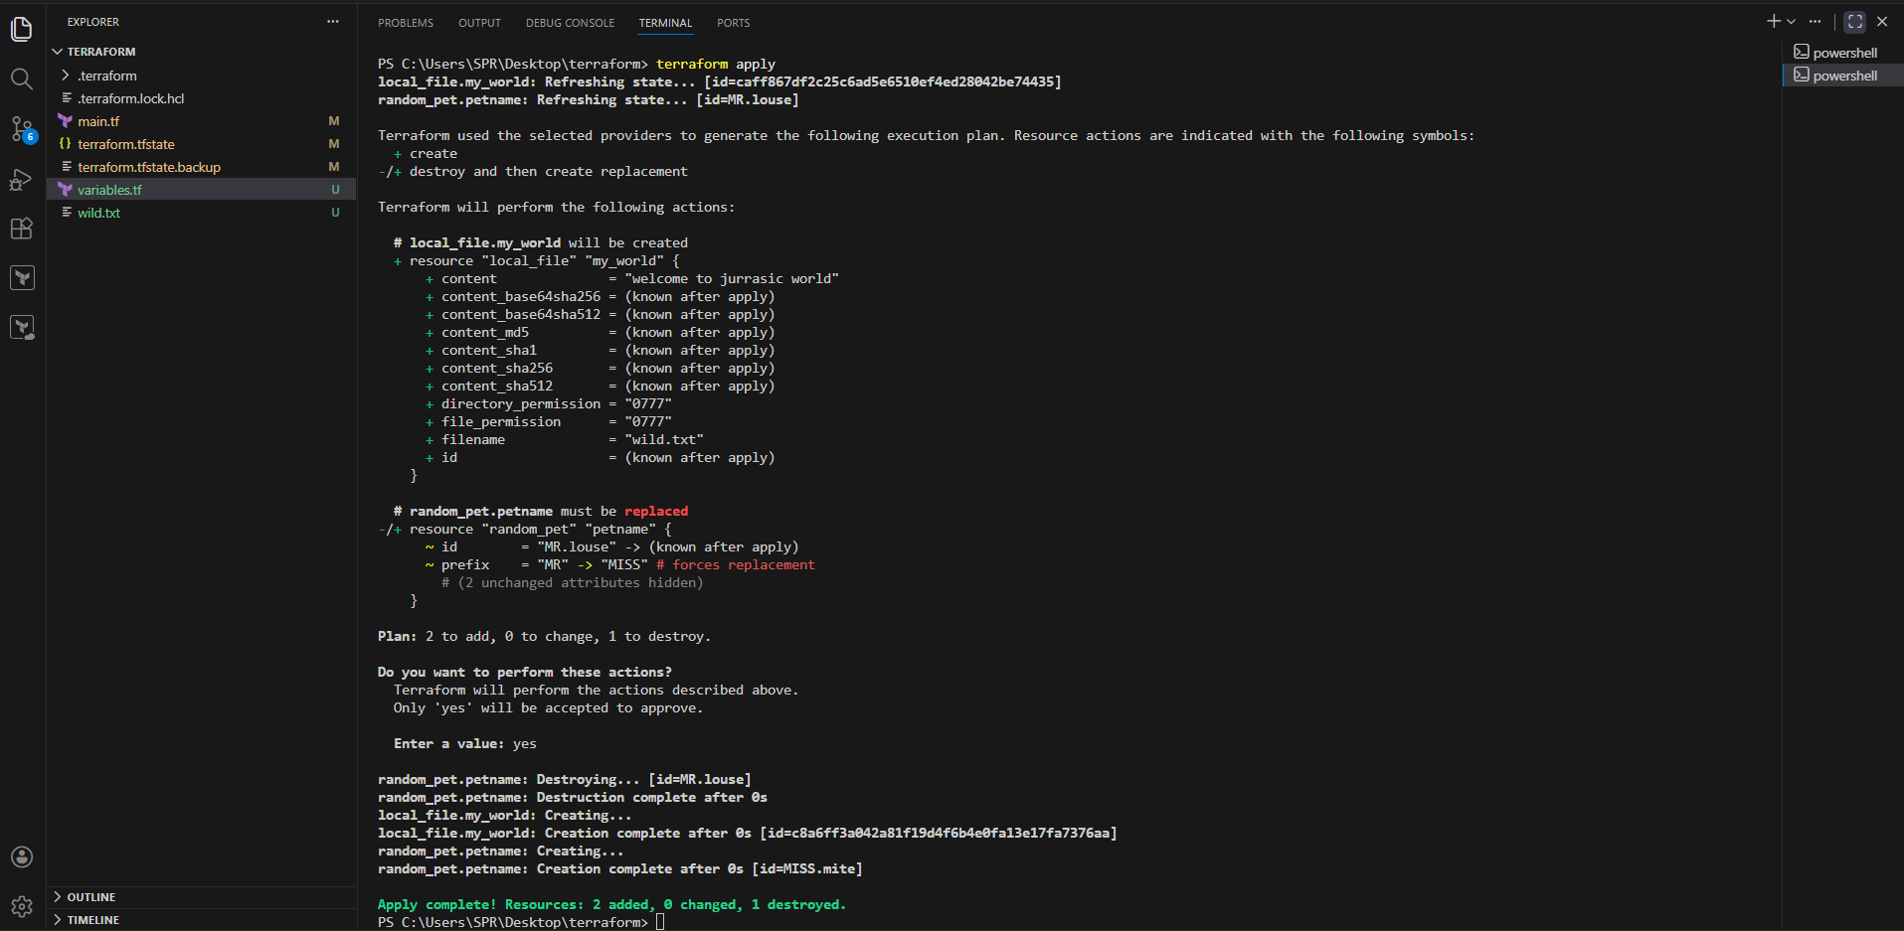

Now I modified the “main.tf ” file .
I need to get the pet_name created should be in the content of the file .

To call the value ${resource.resource-name.id.}
${random_pet.petname.id} ---> random_pet = resource type, petname = resource name,
id = attribute.

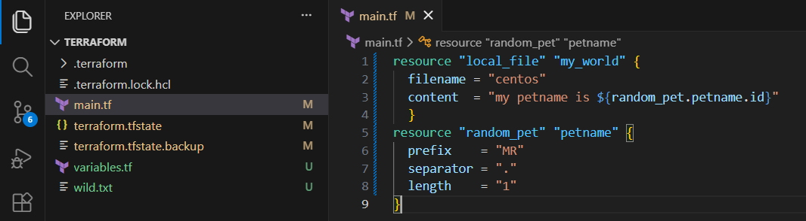

Perform terraform apply

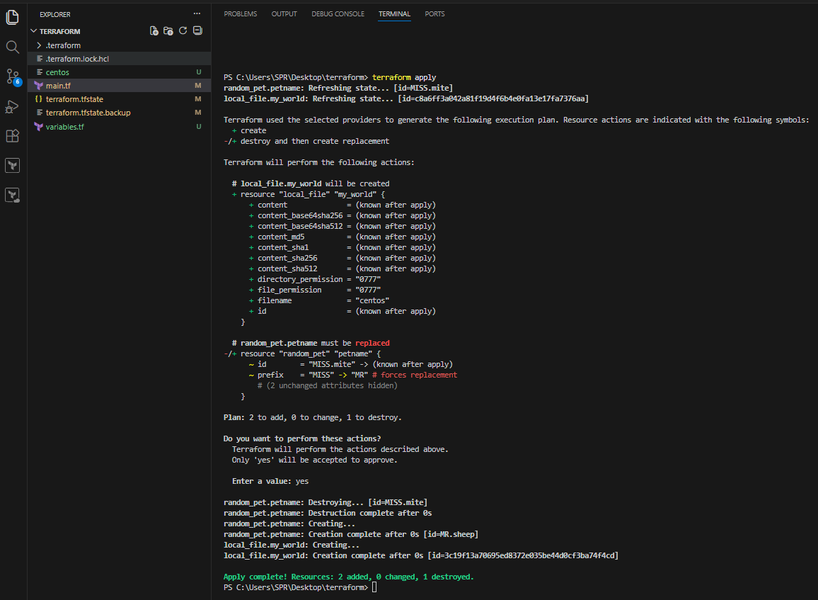

The file got created ,

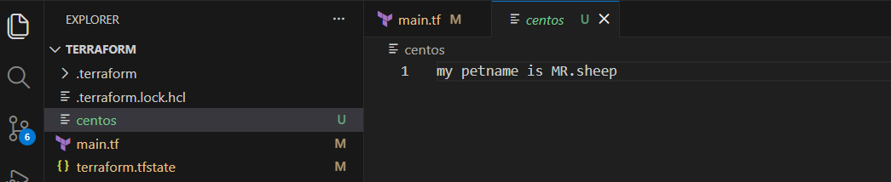
Added output block in “main.tf” , perform terraform apply.

output "petname" {
value = random_pet.petname.id
}

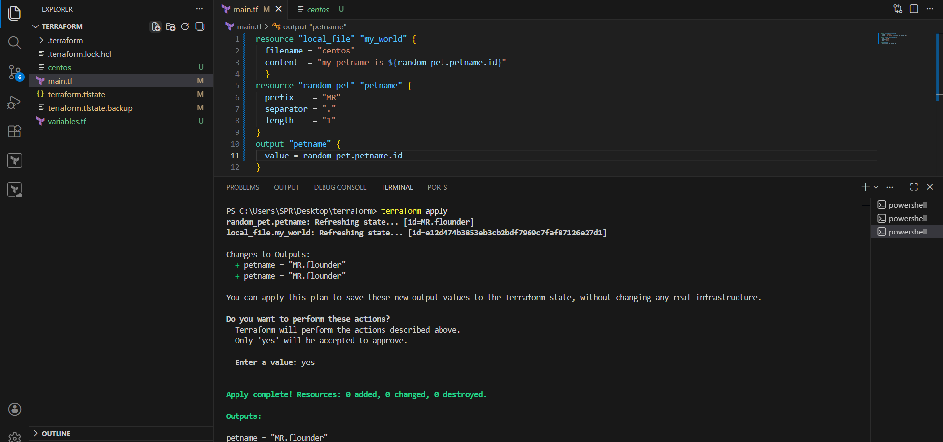

It shows the output as petname= “MR.flounder” ,
And also we can check outputs through command “terraform output”

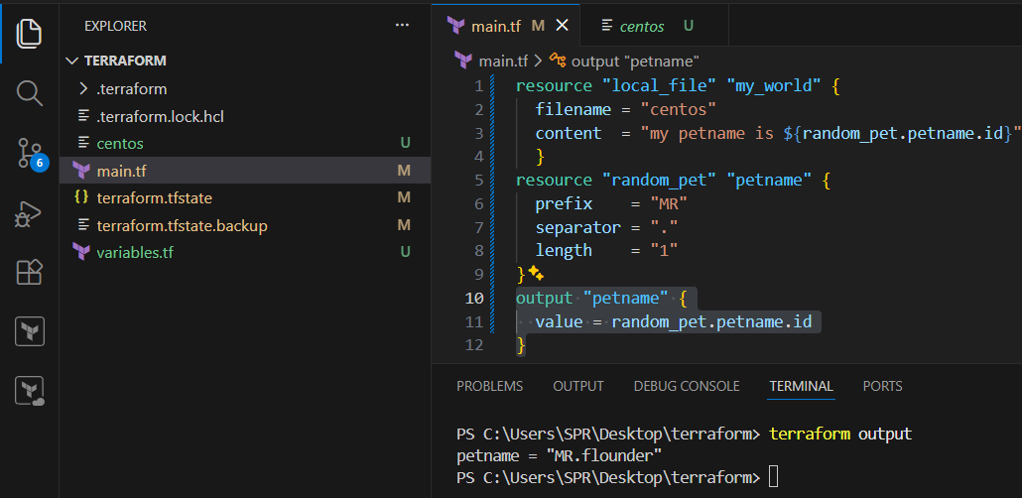

- Integrate Terraform in Jenkins using the Terraform plugin.

1. Prerequisites

Before starting, ensure the following are in place:

### Infrastructure & Software

* Jenkins installed and running
* Java (JDK 11 or 17 recommended)
* Terraform installed on Jenkins server **OR** use Terraform via Jenkins plugin
* Git installed on Jenkins server
* Access to a cloud provider (AWS / Azure / GCP)

### Jenkins Requirements

* Admin access to Jenkins
* Required Jenkins plugins:

* **Terraform Plugin**
* **Git Plugin**
* **Pipeline Plugin**
* **Credentials Binding Plugin**

### Source code management

* Git repository with Terraform code (main.tf, variables.tf, etc.)

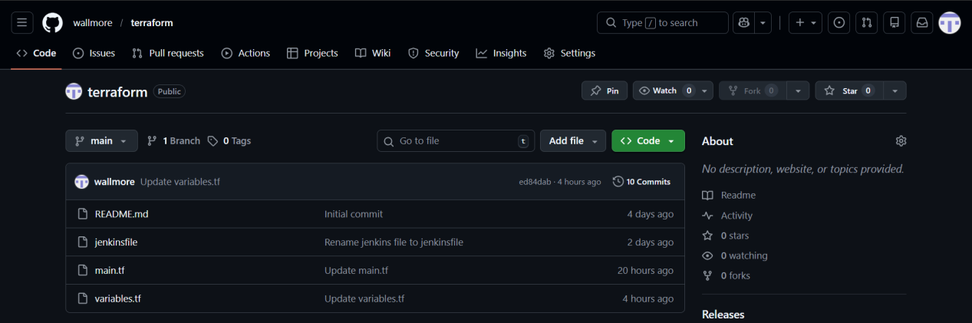

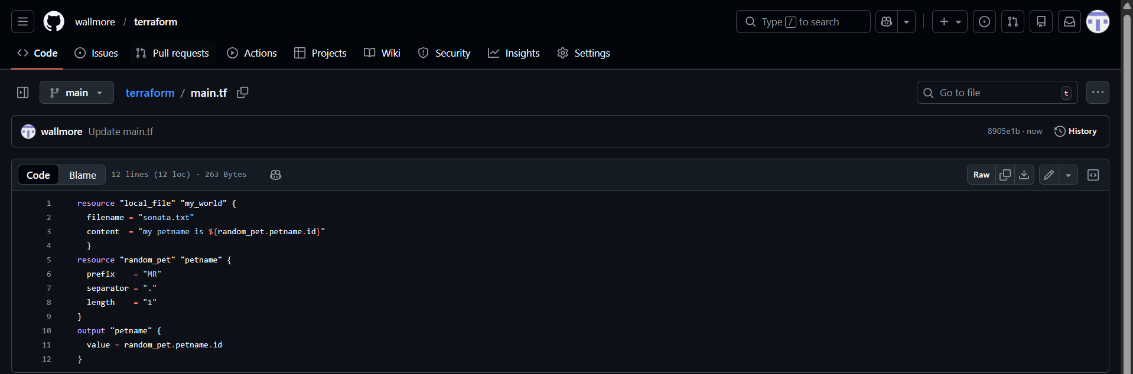

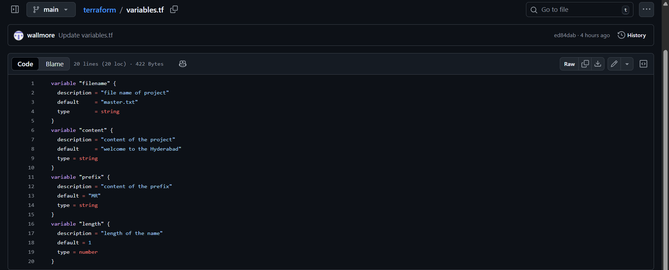

2. Step-by-Step Implementation

### Step 1: Install Terraform , pipeline-stageview , git Plugin in Jenkins

1. Login to Jenkins → **Manage Jenkins** → **Manage Plugins**
2. Go to **Available**
3. Search for **Terraform Plugin , pipeline-stageview , git**
4. Install and restart Jenkins

### Step 2: Configure Terraform Tool in Jenkins

1. Go to **Manage Jenkins** → **Global Tool Configuration**
2. Scroll to **Terraform**
3. Click **Add Terraform**
4. Provide:

* Name: `terraform`
* Install automatically (recommended) OR provide local Terraform path
5. Save

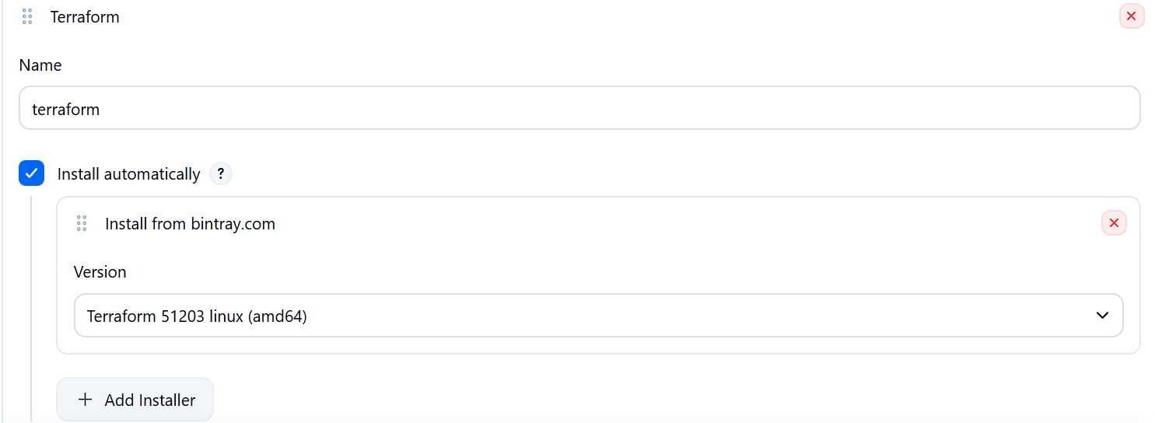

### Step 3: Add Cloud Credentials in Jenkins

1. Go to **Manage Jenkins** → **Credentials**
2. Add new credentials:

* Kind: aws_credentials / acceskeyid & secret-accesskey
* ID: `aws-creds` (example)
3. Save

### Step 4: Create Jenkins Pipeline Job

1. Go to Jenkins Dashboard → **New Item**
2. Select **Pipeline**
3. Name it: `terraform-pipeline`

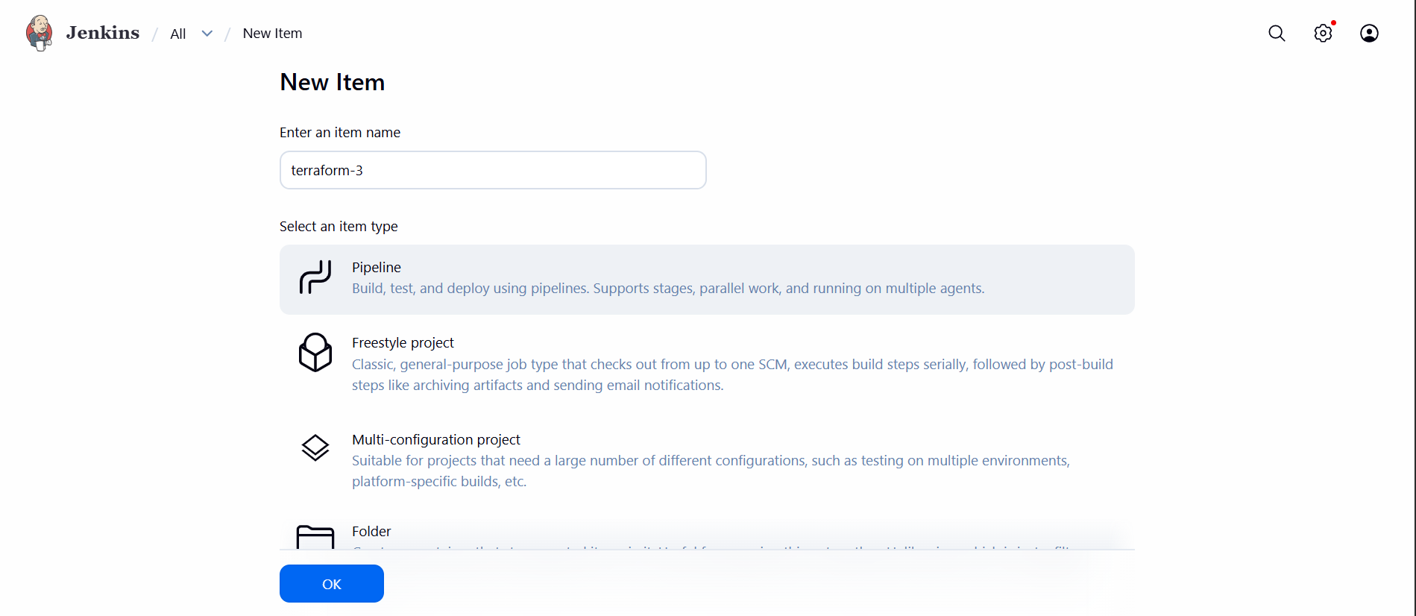

### Step 5: Jenkinsfile (Pipeline Script)

Create a `jenkinsfile` in your Git repo:

pipeline{
agent any
tools {
terraform 'terraform'
}
environment {
GIT_URL = "https://github.com/wallmore/terraform.git"
GIT_BRANCH = "main"
}
stages {
stage('git-clone'){
steps {
git branch:"${GIT_BRANCH}",
url:"${GIT_URL}"
}
}
stage('terraform-init'){
steps {
sh 'terraform init'
}
}
stage('terraform-plan'){
steps {
sh 'terraform plan'
}
}
stage('terraform-apply'){
steps {
sh 'terraform apply -auto-approve'
}
}
}
}

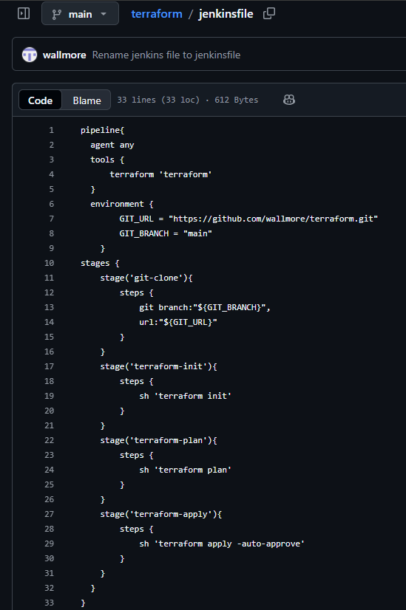

### Step 6: Configure Git Repository in Jenkins Job

* In Pipeline job:

* Definition: **Pipeline script from SCM**
* SCM: Git
* Repository URL: your Terraform repo
* Branch: main
* Script Path: jenkinsfile

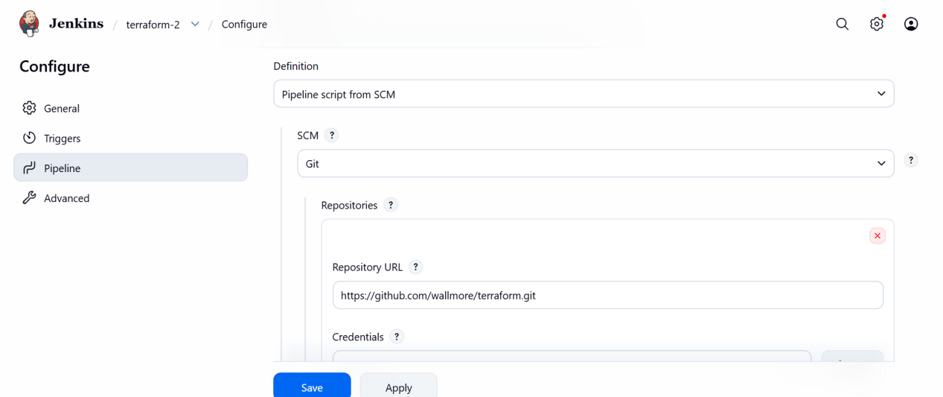
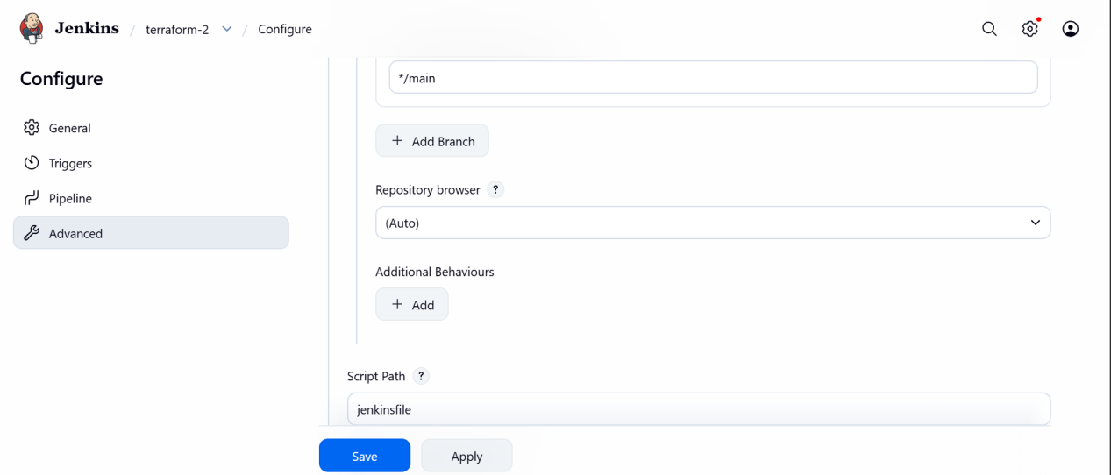

### Step 7: Build the Job

Click **Build Now** to trigger the pipeline.

3. Validation Steps

### Validation 1: Jenkins Console Output

Check Jenkins build logs for:

* `terraform init` completed successfully
* `terraform validate` passed
* `terraform plan` generated
* `terraform apply` executed without errors

### Validation 2: Terraform State

Verify:

* `terraform.tfstate` created (locally or in remote backend like S3)

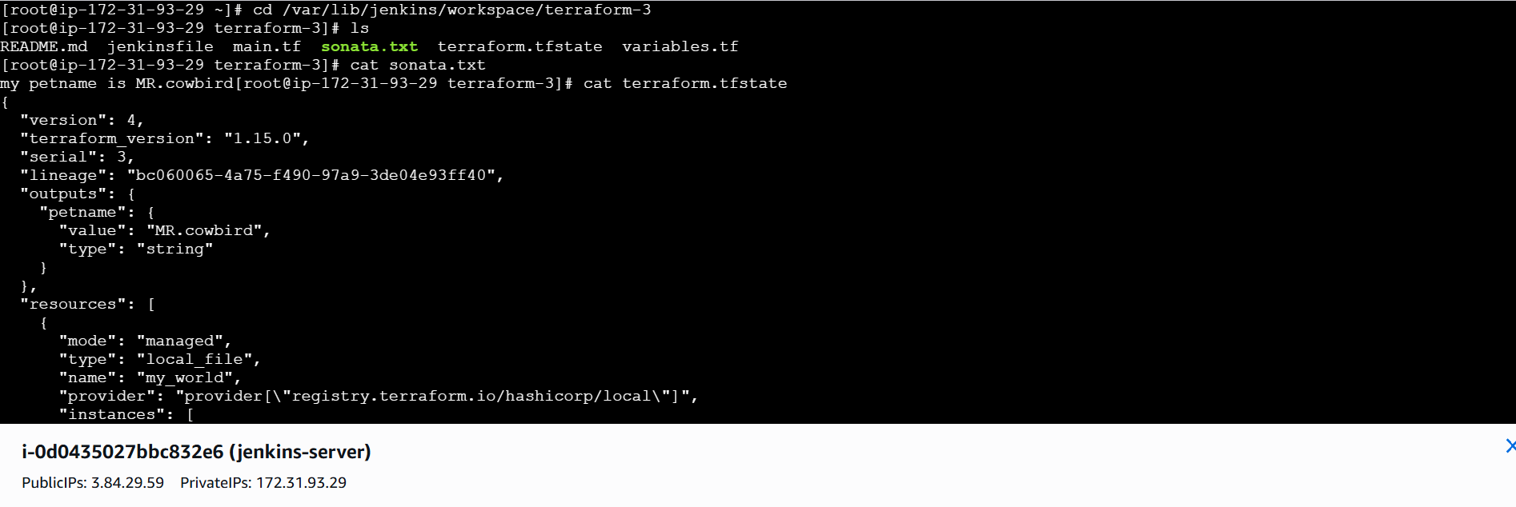

### Validation 4: Jenkins UI

* Job status should be **SUCCESS**
* All stages should be green

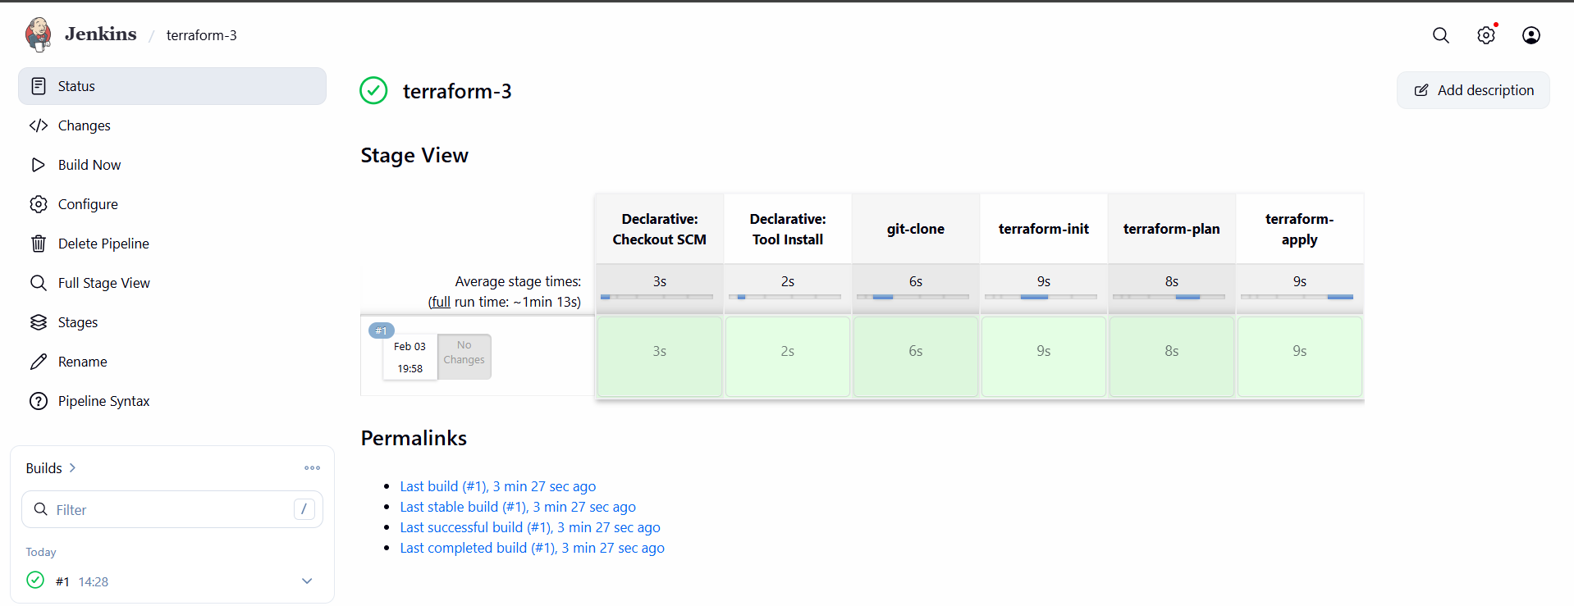

- Create one Jenkins job using Maven Project for the code below with two stages:
Stage 1: Git cloneStage
2: Maven Compilation Code: https://github.com/betawins/java-Working-app.git

1. Prerequisites

Before starting, ensure the following requirements are met:

### Jenkins & System Requirements

* Jenkins installed and running
* Java JDK 8 or above installed on Jenkins server
* Maven installed on Jenkins server
* Git installed on Jenkins server

### Jenkins Plugins

Ensure these plugins are installed:

* **Git Plugin**
* **Maven Integration Plugin**
* **Pipeline (optional, but not needed here)**

### Tool Configuration in Jenkins

Configured under **Manage Jenkins → Global Tool Configuration**:

* JDK (e.g., `jdk11`)
* Maven (e.g., `maven3`)
* Git

### Repository

* GitHub repo URL:
`https://github.com/betawins/java-Working-app.git`

2. Step-by-Step Implementation

### Step 1: Configure Tools in Jenkins

1. Go to **Manage Jenkins → Global Tool Configuration**
2. Configure:

* JDK → Name: `jdk11`
* Maven → Name: `maven3`
* Git → default
3. Save

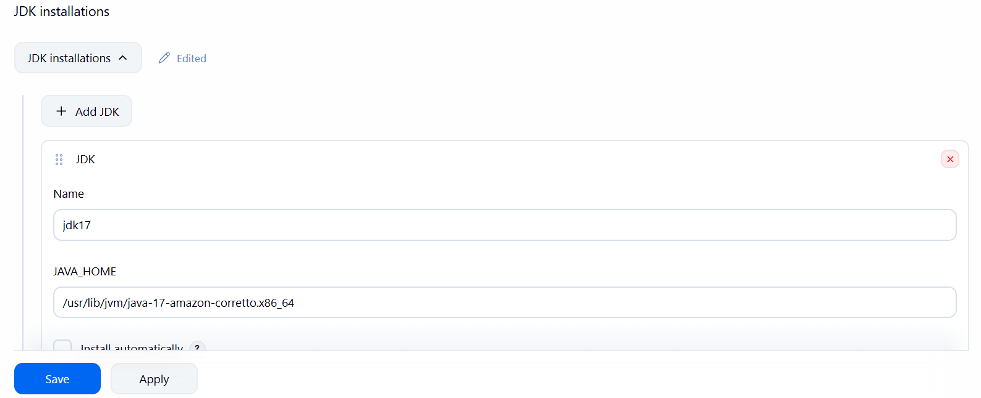

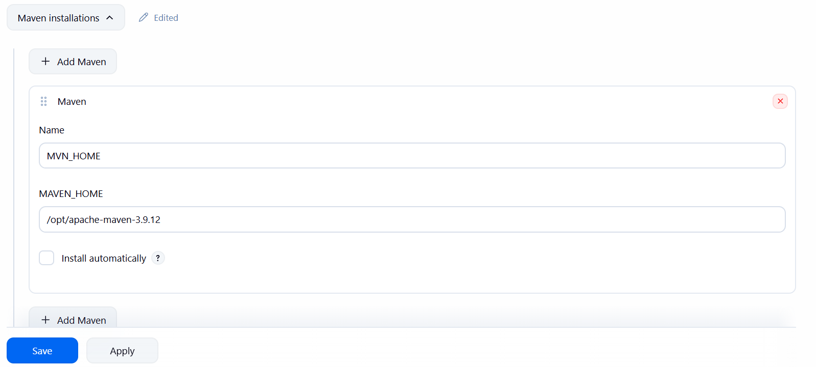

### Step 2: Create Maven Project Job

1. Go to Jenkins Dashboard
2. Click **New Item**
3. Enter Job name:
`java-maven-build`
4. Select **Maven Project**
5. Click **OK**

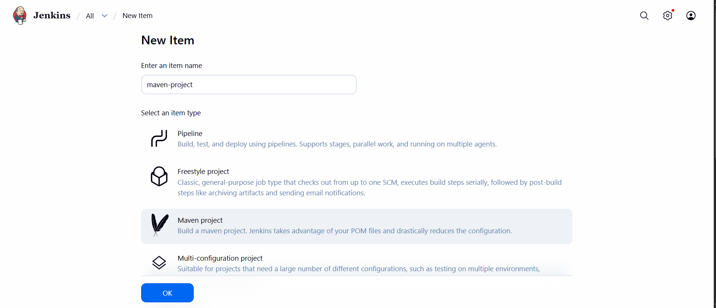

### Step 3: Configure Git Repository (Stage 1: Git Clone)

In job configuration:
1. Under **Source Code Management**
* Select **Git**
* Repository URL:
https://github.com/betawins/java-Working-app.git
* Branch:
*/main
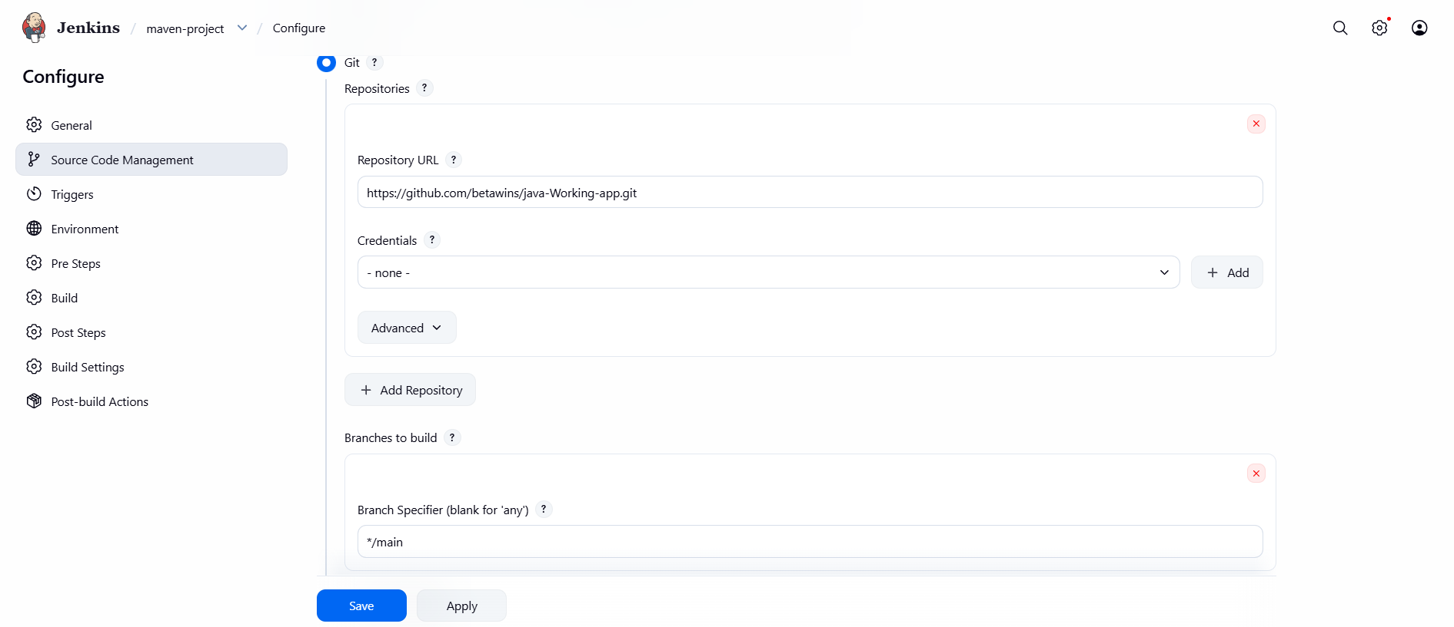

This automatically performs **Git Clone** as Stage 1.

### Step 4: Configure Build Environment

Under **Build Environment**:

* Check:

* ✅ Delete workspace before build starts (optional)
* ✅ Use specific JDK → select `jdk11`

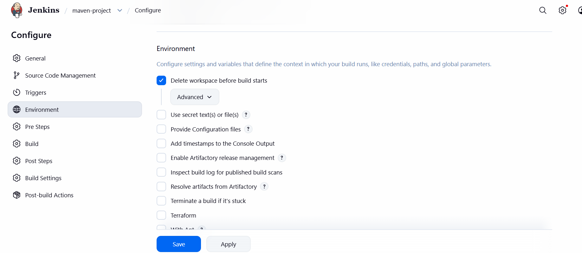
### Step 5: Configure Maven Build (Stage 2: Maven Compilation)

Under **Build** section:

1. Select:

* **Invoke top-level Maven targets**
2. Maven Version: `maven3`
3. Goals:
clean compile

This performs **Maven Compilation** as Stage 2.

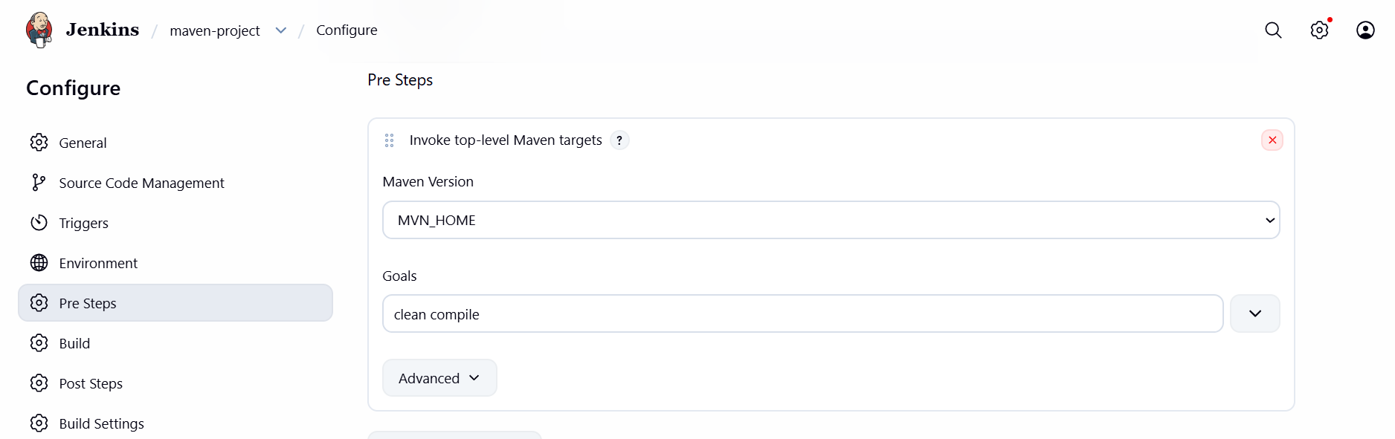

### Step 6: Save the Job

Click **Save**.

3. Validation Steps

### Validation Step 1: Build Execution

1. Click **Build Now**
2. Open **Console Output**

You should see:

* Git clone logs:
Cloning repository https://github.com/betawins/java-Working-app.git
* Maven compile logs:
mvn clean compile
BUILD SUCCESS

### Validation Step 2: Check Workspace

Go to:
Jenkins → Job → Workspace

Confirm:
* `pom.xml` exists
* `target/` directory is created

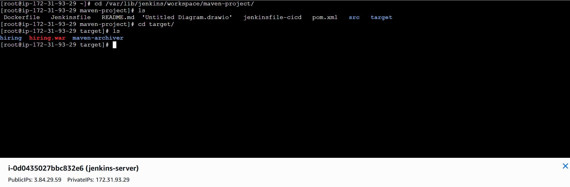

### Validation Step 3: Job Status

* Jenkins job should show:

* ✅ **SUCCESS**
* Both stages executed without errors

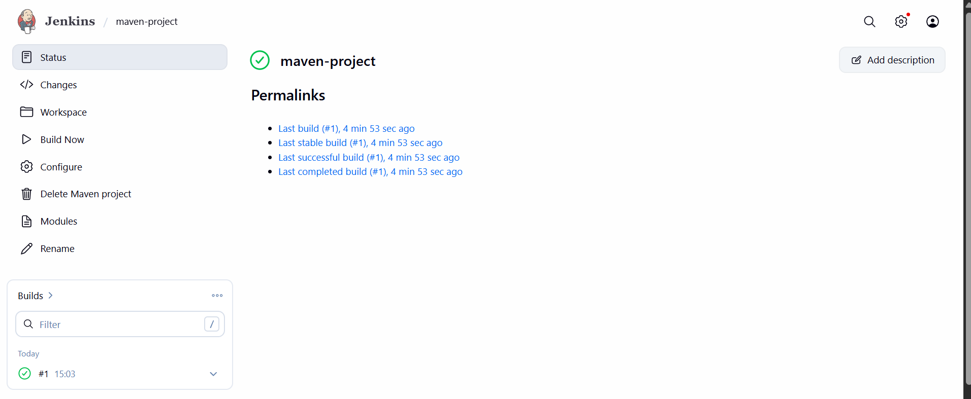

- Use the same code and create a parameterized job in Jenkins with:
Stage 1: Git cloneStage
2: Maven Compilation Code: https://github.com/betawins/java-Working-app.git

- What are the global variables in Jenkins?

1. Built-in Environment Variables (Global for Jobs)

These are available in Freestyle, Maven, and Pipeline jobs.

Common Jenkins global environment variables:

| Variable | Description |
| ----------------- | ------------------------------ |
| `BUILD_NUMBER` | Current build number |
| `BUILD_ID` | Build ID |
| `BUILD_TAG` | Jenkins build tag |
| `JOB_NAME` | Name of the job |
| `WORKSPACE` | Workspace directory |
| `JENKINS_HOME` | Jenkins home directory |
| `NODE_NAME` | Node/agent name |
| `EXECUTOR_NUMBER` | Executor number |
| `BUILD_URL` | URL of the build |
| `JOB_URL` | URL of the job |
| `GIT_COMMIT` | Git commit hash (if using Git) |
| `GIT_BRANCH` | Git branch name |

Example usage:

```bash
echo $BUILD_NUMBER
echo $WORKSPACE
```

## ✅ 2. Pipeline Global Variables (Groovy)

Available in Jenkinsfile (Declarative & Scripted Pipeline).

Common pipeline global variables:

| Variable | Description |
| -------------- | ---------------------------- |
| `env` | Access environment variables |
| `params` | Build parameters |
| `currentBuild` | Build status and result |
| `steps` | Pipeline steps |
| `scm` | Source control configuration |

Example:

```groovy
echo "Build Number: ${env.BUILD_NUMBER}"
echo "Job Name: ${env.JOB_NAME}"
```

